SCHOOL OF COMPUTER SCIENCE AND ARTIFICIAL INTELLIGENCE |  |  |  |  | DEPARTMENT OF COMPUTER SCIENCE ENGINEERING
Program Name: M. Tech/MCA/MSC |  |  |  | Assignment Type: Lab |  |  | AcademicYear:2025-2026
Course Coordinator Name |  |  |  | Venkataramana Veeramsetty
Course Code |  |  |  | Course Title |  | AI Assisted Problem Solving Using Python
Year/Sem |  |  | II/I | Regulation |  | R25
Date and Day  of Assignment |  |  | Week5 - Tuesday | Time(s)
Duration |  |  | 2 Hours | Applicable to  Batches |  | M. Tech/MCA/MSC
AssignmentNumber:14.3(Presentassignmentnumber)/24(Totalnumberofassignments)
 | Q.No. | Question |  |  |  |  |  | ExpectedTime  to complete
 | 1 | Lab 14 – Web Frontend Development: AI-assisted HTML/CSS/JS with Python  Lab Objectives  - To understand how AI can generate HTML/CSS/JS templates.  - To practice integrating frontend and backend (Python) for small apps.  - To evaluate AI-generated code for readability, reusability, and responsiveness.  Learning Outcomes  After completing this lab, students will be able to:  - Generate HTML/CSS layouts using AI tools.  - Add JavaScript interactivity with AI suggestions.  - Integrate basic Python (Flask/Streamlit) backend to serve frontend.  - Evaluate AI-generated web code for responsiveness and usability.  - Debug and refine AI-generated frontend code.  Task Description #1 – AI-generated HTML Page  Task: Ask AI to generate a simple HTML homepage for a "Student Info Portal" with a header, navigation menu, and footer.  prompt  Task Description #1 – AI-generated HTML Page  Task: Ask AI to generate a simple HTML homepage for a "Student Info Portal" with a header, navigation menu, and footer.  Task Description #1 – AI-generated HTML Page  Task: Ask AI to generate a simple HTML homepage for a "Student Info Portal" with a header, navigation menu, and footer.  <!DOCTYPE html>  <html lang="en">  <head>  <meta charset="UTF-8">  <meta name="viewport" content="width=device-width, initial-scale=1.0">  <title>Student Info Portal</title>  <!-- Basic Professional Styling -->  <style>  body {  margin: 0;  font-family: Arial, Helvetica, sans-serif;  background-color: #f5f7fa;  color: #333;  }  header {  background-color: #0a3d62;  color: white;  padding: 20px;  text-align: center;  }  nav {  background-color: #1e3799;  padding: 12px 0;  }  nav ul {  list-style: none;  margin: 0;  padding: 0;  display: flex;  justify-content: center;  gap: 25px;  }  nav ul li a {  color: white;  text-decoration: none;  font-weight: 600;  transition: 0.3s;  }  nav ul li a:hover {  color: #ffdd59;  }  main {  max-width: 900px;  margin: 40px auto;  background: white;  padding: 30px;  border-radius: 8px;  box-shadow: 0 4px 10px rgba(0,0,0,0.1);  }  footer {  text-align: center;  padding: 15px;  background-color: #0a3d62;  color: white;  margin-top: 40px;  }  </style>  </head>  <body>  <!-- ======= Header Section ======= -->  <header>  <h1>Student Info Portal</h1>  <p>Your gateway to academic information</p>  </header>  <!-- ======= Navigation Menu ======= -->  <nav>  <ul>  <li><a href="#">Home</a></li>  <li><a href="#">Student Profiles</a></li>  <li><a href="#">Courses</a></li>  <li><a href="#">Results</a></li>  <li><a href="#">Support</a></li>  </ul>  </nav>  <!-- ======= Main Content Section ======= -->  <main>  <h2>Welcome to the Portal</h2>  <p>  The Student Info Portal allows students to access important academic data  including course details, personal profiles, examination results,  and support services. Our goal is to provide a seamless and user-friendly  platform for all your academic needs.  </p>  <h3>Features</h3>  <ul>  <li>View and update student profile</li>  <li>Check course curriculum and materials</li>  <li>Access academic performance reports</li>  <li>Download certificates and official documents</li>  </ul>  </main>  <!-- ======= Footer Section ======= -->  <footer>  &copy; 2025 Student Info Portal | Designed for Student Services  </footer>  </body>  </html>  Expected Output:  - HTML code with <header>, <nav>, <footer>.  - Clean indentation, proper tags, and comments.  Result  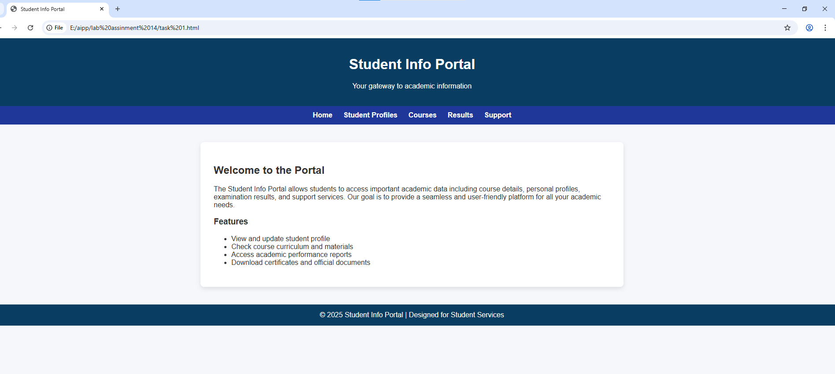  Task Description #2 – CSS Styling  Task:  Use AI to add CSS styling to Task #1 homepage for:  - Responsive navigation bar.  - Centered content section.  Footer with light gray background.  <!DOCTYPE html>  <html lang="en">  <head>  <meta charset="UTF-8">  <meta name="viewport" content="width=device-width, initial-scale=1.0">  <title>Student Info Portal</title>  <style>  /* ---------- GLOBAL STYLING ---------- */  body {  margin: 0;  font-family: "Segoe UI", Arial, sans-serif;  background-color: #f3f4f6;  color: #333;  line-height: 1.6;  }  /* ---------- HEADER ---------- */  header {  background: linear-gradient(90deg, #003c8f, #0059c1);  color: white;  padding: 35px 20px;  text-align: center;  box-shadow: 0px 3px 8px rgba(0,0,0,0.2);  }  header h1 {  margin: 0;  font-size: 2.3rem;  font-weight: 700;  }  header p {  margin-top: 8px;  font-size: 1rem;  opacity: 0.9;  }  /* ---------- NAVIGATION ---------- */  nav {  background-color: #0747a6;  box-shadow: 0 2px 5px rgba(0,0,0,0.1);  }  .nav-links {  list-style: none;  margin: 0;  padding: 12px 0;  display: flex;  justify-content: center;  gap: 35px;  flex-wrap: wrap;  }  .nav-links a {  text-decoration: none;  color: white;  font-weight: 600;  padding: 8px 14px;  border-radius: 5px;  transition: all 0.3s ease;  font-size: 0.95rem;  }  .nav-links a:hover {  background-color: #ffda47;  color: #003c8f;  }  /* ---------- MAIN CONTENT ---------- */  .content-wrapper {  max-width: 1000px;  margin: 50px auto;  background: white;  padding: 40px;  border-radius: 12px;  box-shadow: 0 4px 15px rgba(0,0,0,0.12);  animation: fadeIn 0.7s ease;  }  .content-wrapper h2 {  margin-top: 0;  font-size: 1.8rem;  color: #003c8f;  }  .content-wrapper ul {  margin-top: 10px;  }  .content-wrapper ul li {  margin-bottom: 8px;  }  /* ---------- FOOTER ---------- */  footer {  background-color: #e8e8e8; /* Light gray */  color: #555;  text-align: center;  padding: 18px;  font-size: 0.95rem;  margin-top: 60px;  border-top: 1px solid #d4d4d4;  }  /* ---------- RESPONSIVE NAVIGATION ---------- */  @media (max-width: 650px) {  .nav-links {  flex-direction: column;  gap: 15px;  }  }  /* Smooth fade-in animation */  @keyframes fadeIn {  from { opacity: 0; transform: translateY(20px); }  to { opacity: 1; transform: translateY(0); }  }  </style>  </head>  <body>  <!-- ---------- HEADER SECTION ---------- -->  <header>  <h1>Student Info Portal</h1>  <p>Your gateway to academic resources and student services</p>  </header>  <!-- ---------- NAVIGATION ---------- -->  <nav>  <ul class="nav-links">  <li><a href="#">Home</a></li>  <li><a href="#">Student Profiles</a></li>  <li><a href="#">Courses</a></li>  <li><a href="#">Results</a></li>  <li><a href="#">Support</a></li>  </ul>  </nav>  <!-- ---------- MAIN CONTENT ---------- -->  <section class="content-wrapper">  <h2>Welcome to the Portal</h2>  <p>  This Student Info Portal provides streamlined access to essential academic records,  course materials, examination results, and personalized student information.  Designed with a clean and modern user interface, our goal is to enhance your  overall learning experience.  </p>  <h3>Portal Features</h3>  <ul>  <li>✔ Access and update personal student profiles</li>  <li>✔ View detailed academic curriculum and course materials</li>  <li>✔ Check semester-wise academic performance</li>  <li>✔ Download certificates and official documents</li>  </ul>  </section>  <!-- ---------- FOOTER ---------- -->  <footer>  © 2025 Student Info Portal | Designed with Excellence  </footer>  </body>  </html>  Expected Output:  - HTML + CSS combined.  - AI explains how CSS classes apply.  Expected Output: AI refactors with with open() and try-except:  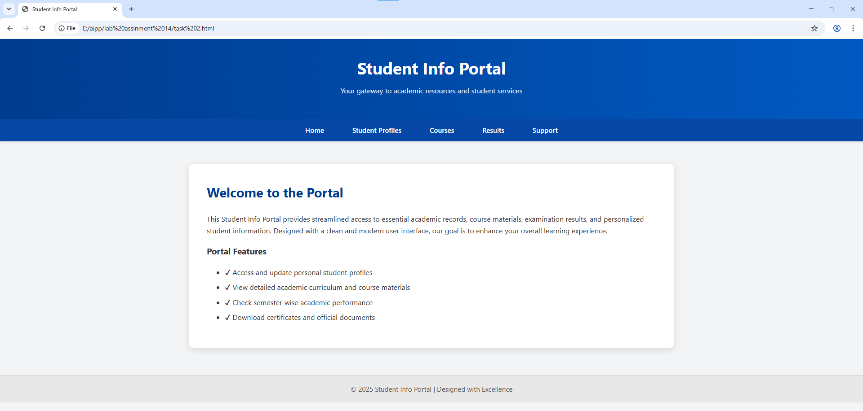  Task Description #3 – JavaScript Interactivity  Task: Prompt AI to generate a JS script that validates a simple login form (non-empty username/password).  prompt  Task Description #3 – JavaScript Interactivity  Task: Prompt AI to generate a JS script that validates a simple login form (non-empty username/password).  <!DOCTYPE html>  <html lang="en">  <head>  <meta charset="UTF-8">  <meta name="viewport" content="width=device-width, initial-scale=1.0">  <title>Student Info Portal - Login</title>  <style>  body {  margin: 0;  background: #e5e7eb;  font-family: Arial, sans-serif;  display: flex;  justify-content: center;  align-items: center;  height: 100vh;  }  .login-box {  background: white;  width: 350px;  padding: 30px;  border-radius: 10px;  box-shadow: 0 6px 18px rgba(0,0,0,0.2);  }  .login-box h2 {  text-align: center;  margin-bottom: 20px;  color: #1e3a8a;  }  .input-group {  margin-bottom: 18px;  }  .input-group label {  font-weight: 600;  display: block;  margin-bottom: 5px;  }  .input-group input {  width: 100%;  padding: 10px;  border: 1.5px solid #ccc;  border-radius: 6px;  font-size: 0.95rem;  }  .input-group input.error {  border-color: red;  }  .error-message {  color: red;  font-size: 0.8rem;  display: none;  margin-top: 4px;  }  .login-btn {  width: 100%;  padding: 12px;  background: #1e3a8a;  color: white;  border: none;  border-radius: 6px;  font-size: 1rem;  cursor: pointer;  margin-top: 5px;  }  .login-btn:hover {  background: #1d4ed8;  }  </style>  </head>  <body>  <div class="login-box">  <h2>Portal Login</h2>  <form id="loginForm">  <div class="input-group">  <label for="username">Username</label>  <input type="text" id="username">  <div class="error-message" id="userError">Username is required.</div>  </div>  <div class="input-group">  <label for="password">Password</label>  <input type="password" id="password">  <div class="error-message" id="passError">Password is required.</div>  </div>  <button type="submit" class="login-btn">Login</button>  </form>  </div>  <script>  const form = document.getElementById("loginForm");  const username = document.getElementById("username");  const password = document.getElementById("password");  const userError = document.getElementById("userError");  const passError = document.getElementById("passError");  form.addEventListener("submit", function(e) {  e.preventDefault();  let valid = true;  // Username validation  if (username.value.trim() === "") {  username.classList.add("error");  userError.style.display = "block";  valid = false;  } else {  username.classList.remove("error");  userError.style.display = "none";  }  // Password validation  if (password.value.trim() === "") {  password.classList.add("error");  passError.style.display = "block";  valid = false;  } else {  password.classList.remove("error");  passError.style.display = "none";  }  // Success  if (valid) {  alert("Login Successful!");  }  });  </script>  </body>  </html>  Expected Output:  Working on submit JS validation.  Clear error messages if inputs are empty.  Result  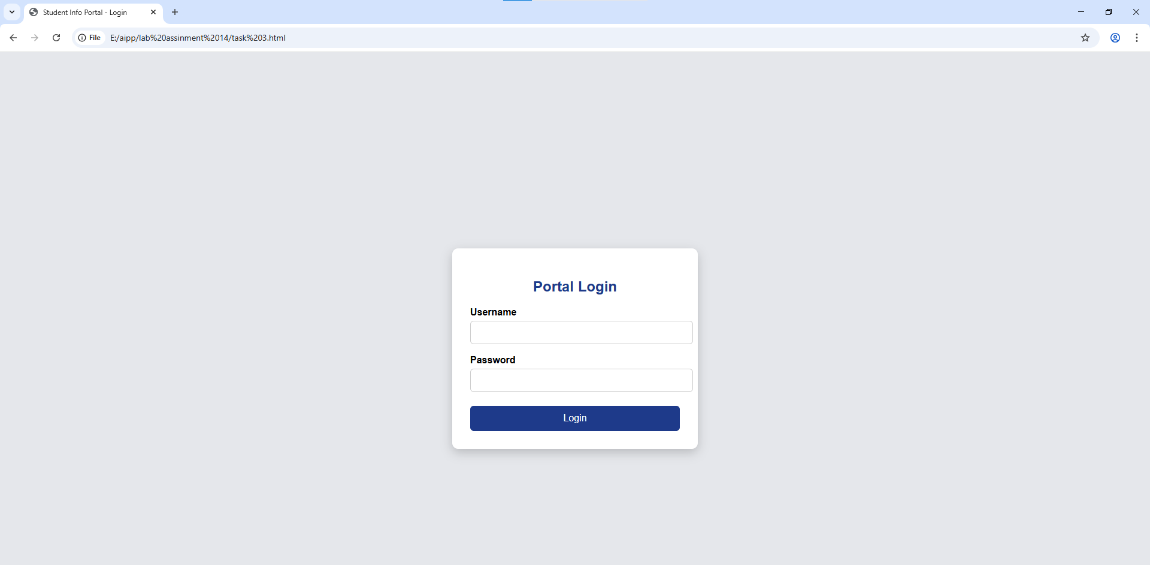  Task Description #4 – Python Backend Integration  Task: Ask AI to generate a Flask app that serves the HTML form (Task #3) and prints the username on successful login.  prompt  Task Description #4 – Python Backend Integration  Task: Ask AI to generate a Flask app that serves the HTML form (Task #3) and prints the username on successful login.  give me fancy code  from flask import Flask, request, render_template_string  app = Flask(__name__)  html_form = '''  <!DOCTYPE html>  <html lang="en">  <head>  <meta charset="UTF-8">  <meta name="viewport" content="width=device-width, initial-scale=1.0">  <title>Professional Login</title>  <style>  * { margin: 0; padding: 0; box-sizing: border-box; }  body {  font-family: 'Segoe UI', Tahoma, Geneva, Verdana, sans-serif;  background: linear-gradient(135deg, #667eea 0%, #764ba2 100%);  min-height: 100vh;  display: flex;  align-items: center;  justify-content: center;  }  .login-container {  background: rgba(255, 255, 255, 0.95);  padding: 2.5rem;  border-radius: 20px;  box-shadow: 0 20px 40px rgba(0,0,0,0.1);  width: 100%;  max-width: 400px;  backdrop-filter: blur(10px);  }  h1 {  text-align: center;  color: #333;  margin-bottom: 2rem;  font-size: 2rem;  font-weight: 300;  }  .form-group {  position: relative;  margin-bottom: 1.5rem;  }  label {  display: block;  margin-bottom: 0.5rem;  color: #555;  font-weight: 500;  }  input[type="text"], input[type="password"] {  width: 100%;  padding: 1rem 1rem 1rem 2.5rem;  border: 2px solid #e1e5e9;  border-radius: 12px;  font-size: 1rem;  transition: all 0.3s ease;  background: #f8f9fa;  }  input:focus {  outline: none;  border-color: #667eea;  background: white;  box-shadow: 0 0 0 3px rgba(102, 126, 234, 0.1);  transform: translateY(-2px);  }  .input-icons {  position: absolute;  left: 1rem;  top: 2.8rem;  color: #888;  }  button {  width: 100%;  padding: 1.2rem;  background: linear-gradient(135deg, #667eea 0%, #764ba2 100%);  color: white;  border: none;  border-radius: 12px;  font-size: 1.1rem;  font-weight: 600;  cursor: pointer;  transition: all 0.3s ease;  text-transform: uppercase;  letter-spacing: 1px;  }  button:hover {  transform: translateY(-3px);  box-shadow: 0 15px 30px rgba(102, 126, 234, 0.4);  }  .success { text-align: center; color: #28a745; font-size: 1.2rem; margin-top: 1rem; }  </style>  </head>  <body>  <div class="login-container">  <h1>Welcome Back</h1>  <form action="/login" method="post">  <div class="form-group">  <label for="username">Username</label>  <i class="input-icons">👤</i>  <input type="text" id="username" name="username" required>  </div>  <div class="form-group">  <label for="password">Password</label>  <i class="input-icons">🔒</i>  <input type="password" id="password" name="password" required>  </div>  <button type="submit">Sign In</button>  </form>  <div id="success" class="success" style="display: none;"></div>  </div>  <script>  // Simple client-side success display  if (window.location.pathname === '/login' && {{ request.form.get('username') or 'null' }}) {  document.getElementById('success').style.display = 'block';  document.getElementById('success').textContent = 'Login successful! Welcome back!';  }  </script>  </body>  </html>  '''  @app.route('/')  def serve_form():  return render_template_string(html_form)  @app.route('/login', methods=['POST'])  def login():  username = request.form.get('username')  print(f"✅ User logged in: {username}") # Server-side print with emoji  return f'''  <!DOCTYPE html>  <html>  <head><title>Success</title></head  result  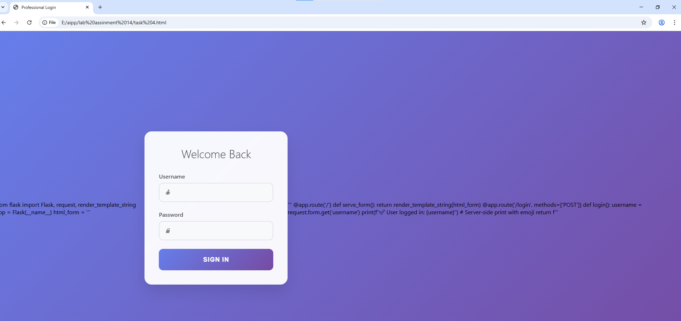 |  |  |  |  |  | Week5 - Tuesday

